(Approx. 1072 words)

What’s New?
Reviews by George Harding, Treasurer, Tucson Computer Society, AZ
September 2016
www.aztcs.org
georgehardingsbd (at) earthlink.net

Ionbank …

External batteries are pretty much a necessity for those of us who go outside the house frequently. One has to look ahead to keep devices charged up sufficiently.

The Ionbank is a finely manufactured piece of hardware that not only serves the need to charge a device when needed, but also is a handsome piece of equipment.

Ionbank has a nifty anodized aluminum case with a narrow hinged lid that exposes two cables.

One cable has the Lightning plug for recent iPhones. The other has a standard USB plug, which is used to charge the Ionbank. The two cables fold neatly into the interior compartment and are covered by the hinged lid.
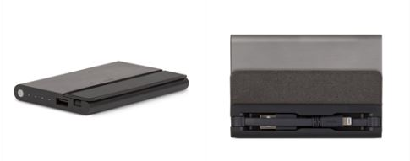
There is a USB socket on one end of the device, which can be used to charge using the cable that came with your smartphone. One advantage of the Ionbank system is that you can use both cables; one will charge your smartphone first then the other will charge the Ionbank.

On that same end is a small button and four LED lights to indicate the Ionbank’s charge capacity. Four LEDs indicates 100%, three75%and so on.

You press the small button to check charge capacity and to start charging your phone. I’m able to charge my iPhone twice using the Ionbank before it needs recharging.

The product includes a small booklet with Instructions and Important Information in English and several other languages. The English portion is two short pages, but is complete and concise.

Warranty is one year, but will be extended to two years when you register.

Ionbank 5K by Moshi www.moshi.com Price $80

Bowery Energy Bag …

If you’re like me, you have a laptop, tablet and cell phone. You need to carry all this whenever you travel, but doing so is kind of clumsy. It’s easy to find a laptop carry bag, but what about the tablet and cell phone?

Here’s the solution, the STM Bowery Energy Bag. It has many pockets, but the most important are the padded ones for your laptop, tablet and cell phone. There are many other pockets, as well for pen, pencil, business cards and other stuff you will need on your trip.

But best of all is the ability to charge your items while you travel. The Bowery Energy Bag includes a lithium ion battery that is accessed through the Joey, a small device with a USB outlet and a micro-USB outlet.
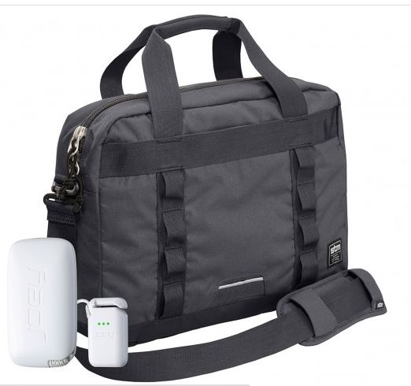
These can be used for both charging the lithium ion battery, but also to charge one or more of your devices. You can arrive at your destination with devices fully charged and without the need for several cords and charging units.

All this comes with a bag that is both attractive and quite durable. The main pockets are zippered for security. There are handles for carrying by hand, by over the shoulder strops and even across the body strap.

There is an additional band on the back of the bag that can be used to attach to your wheeled luggage. Then you don’t even have to carry the bag!
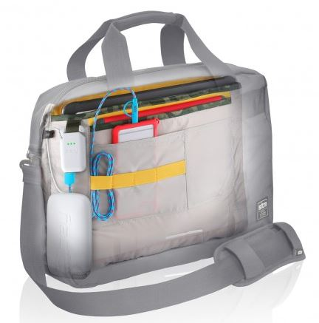
The manufacturer includes several informative items. One is the Quick Start guide, a visual aid to operation with brief explanations of how to connect for charging the built-in battery and also for charging any of your devices. Another is a warranty booklet in several languages.

The outside of the bag has a few hanging tags, one of which tells succinctly what the bag does for you.

A unique benefit of STM bags is the availability of return of lost bags. You register your bag with STM, providing your information. If the bag is lost, there is a tag inside which can be used to connect with STM, who will provide the means for returning the bag to you. What a deal!
Bowery Energy Bag by STM www.stmbags.com Price $200

Siggrapph …

This is a different sort of computer show that I attend when it’s within driving distance. This year Anaheim Convention Center was the venue. It’s a very attractive and busy place, being very close to Disneyland Park.


Siggraph is a SIG (Special Interest Group) of the Association for Computing Machinery, a name that appears to have stood the test of time! Siggraph brings together companies of four types.

First, there are those that produce movies and video games using very high-end software and hardware. The products created are full of CGI or computer graphics information. That is, what you see looks real, but is not. The process involves creation of images in several ways, animating them to produce motion, then rendering the result to produce the finished product. Some of these companies are Disney, Industrial Light and Magic, Pixar and Marvel Entertainment.

Second, there are the companies that provide the hardware used for these processes. This hardware is much faster and more capable (and more expensive) than the laptops and computers you and I use daily. Some of these companies are Intel, Nvidia and Boxx. Other hardware is used for rendering.

Third, there are the companies that provide the software used for image creation and animation. One such is Houdini.
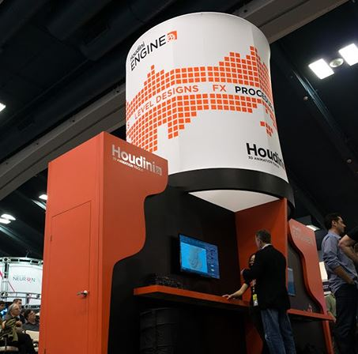
Fourth, there are the educational institutions that teach techniques and train students to do image creation, animation and other aspects of the movies and video games. Ringling College of Arts, University of the Arts Philadelphia, Vancouver Film School and SCAD (South Carolina Arts and Design) were present this year.

The show offers several other events that are interesting and informative:
- Training sessions. These seem to be very technical and are for those who want to learn how to do some of the complicated stuff.
- Art papers. Complex drawings done by computer graphics.
- Production sessions. These are companies like Pixar to show how they created Finding Dory, for example. The ones I attended were fascinating!
- Emerging technologies. This area has some 30 exhibitors showing an experimental technique or display technology.
- VR Village. Several companies show their products created so far.
- Animation Festival. This is one of the most interesting and entertaining events. During a two-hour show, CG presentations by individuals and companies are exclusively CG – no humans at all. Each presentation ranges from 2 minutes to 15 or 20 minutes.
- Keynotes.

Siggraph is a very interesting show. I look forward to going to it each time.

Siggraph by ACM s2016.siggraph.org

